**POLITECNICO DI MILANO**

**Scuola di Ingegneria Industriale e dell'Informazione**

**Corso di Laurea in Ingegneria Elettrica**



Field Oriented Control of an induction motor of a train

Alessandro Secchi

Matr. 944668

For the motor model, a stationary reference frame has ben chosen:

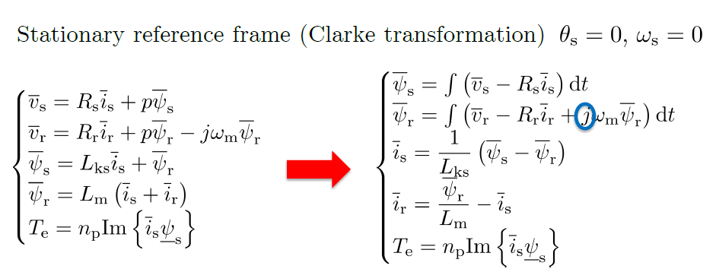

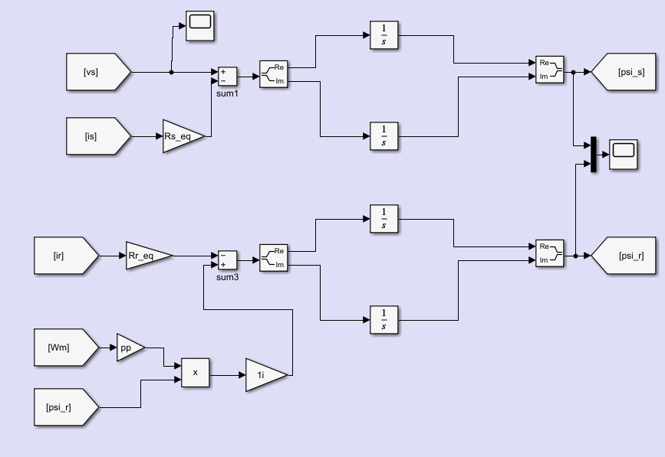

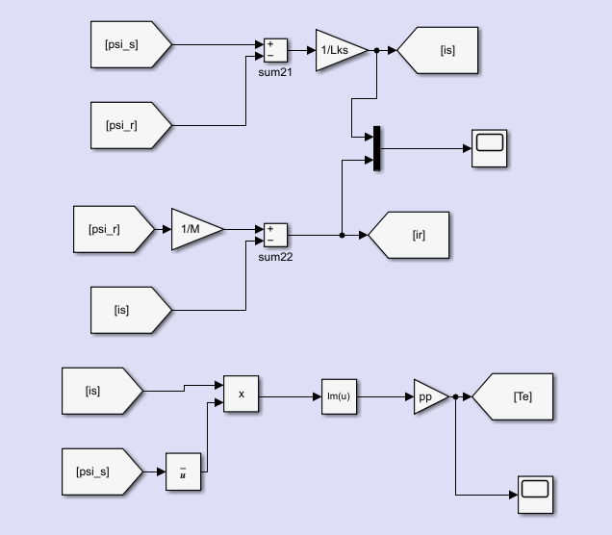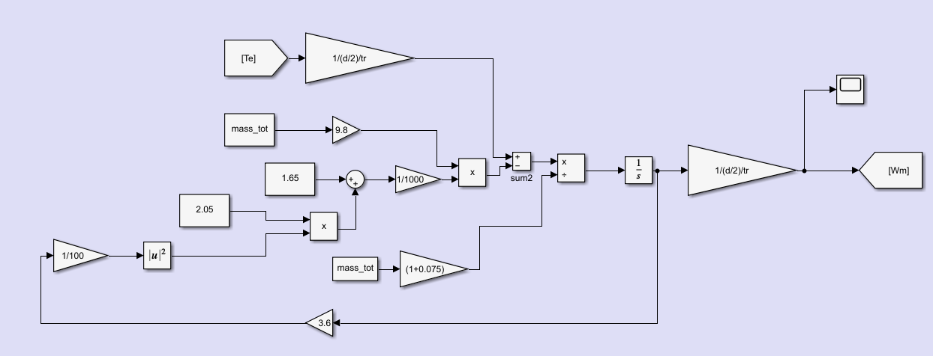

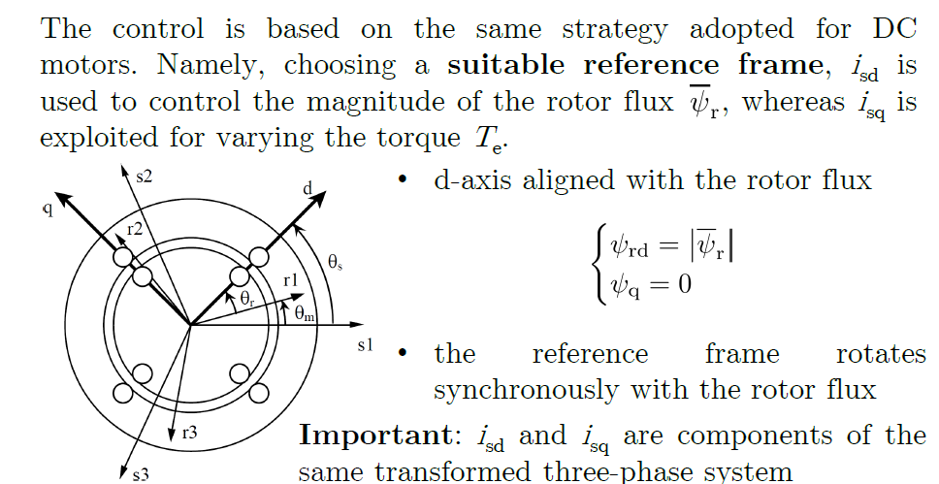

For the control scheme, instead:

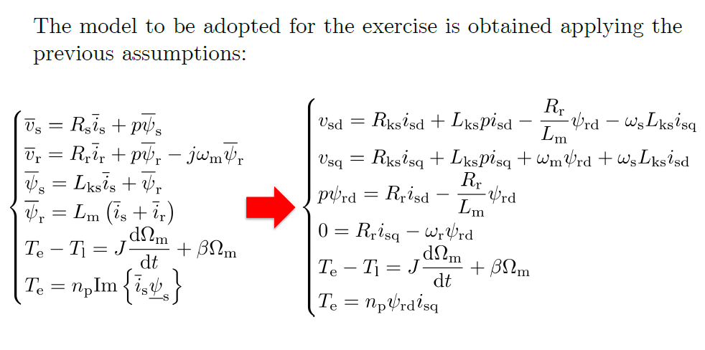

The vector control try to follow the idea of the DC drive.

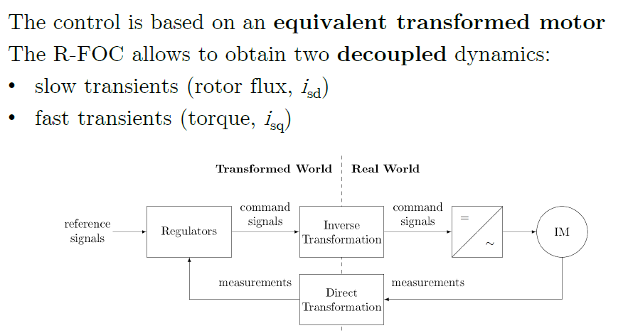

Speed and isd regulators with the decoupling terms:

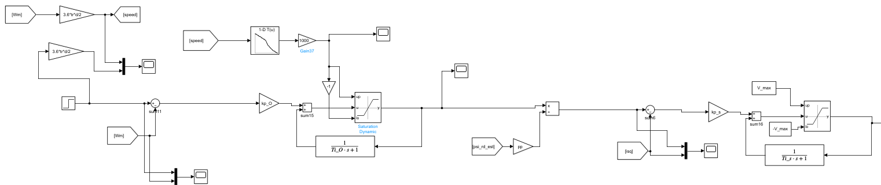

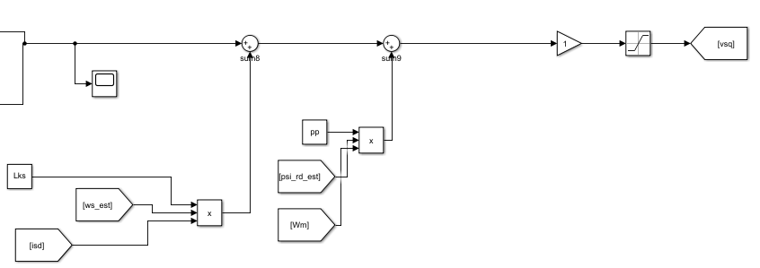

Flux and isq regulator with decoupling terms:

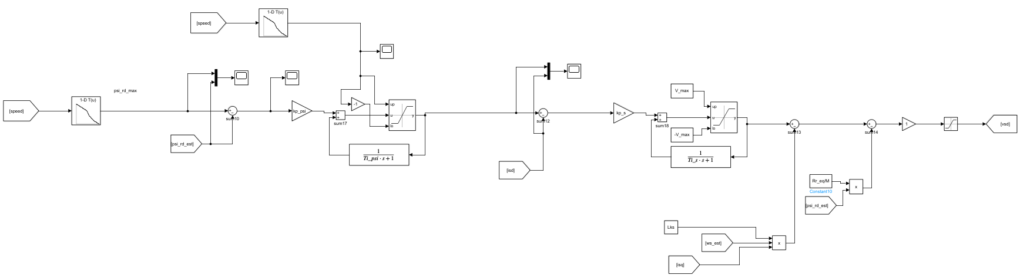

The estimators are a fundamental part of the control scheme.

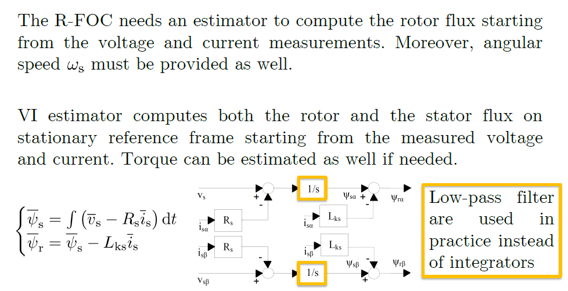

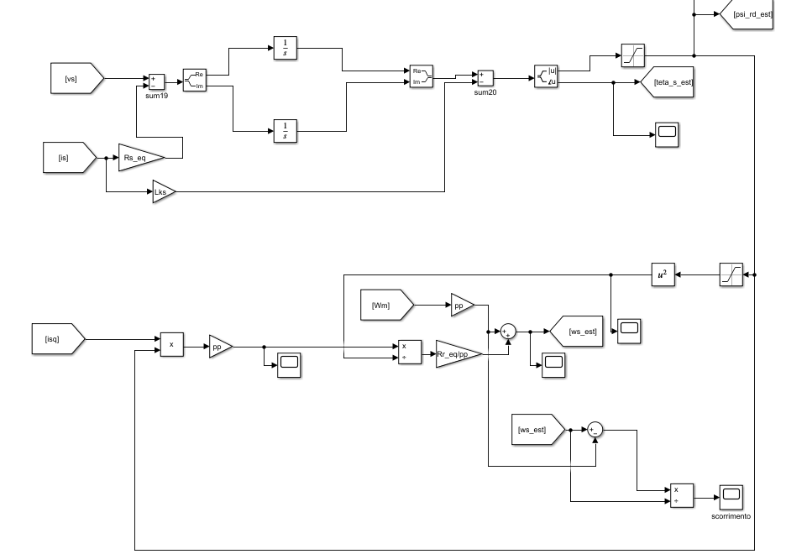

In order to pass from dq reference frame to space phasor and viceversa, the following blocks are also needed:

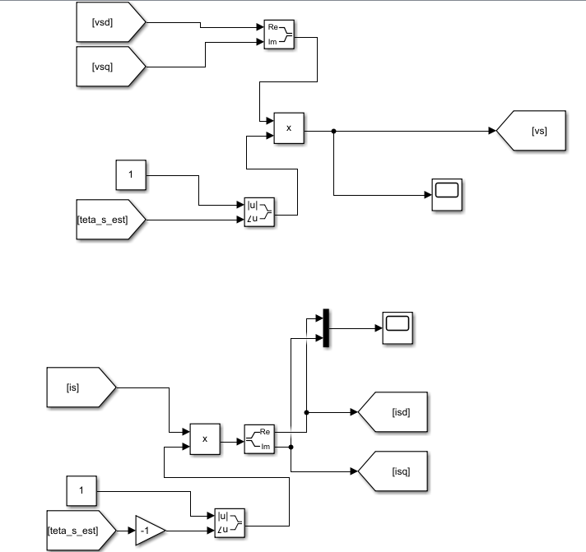

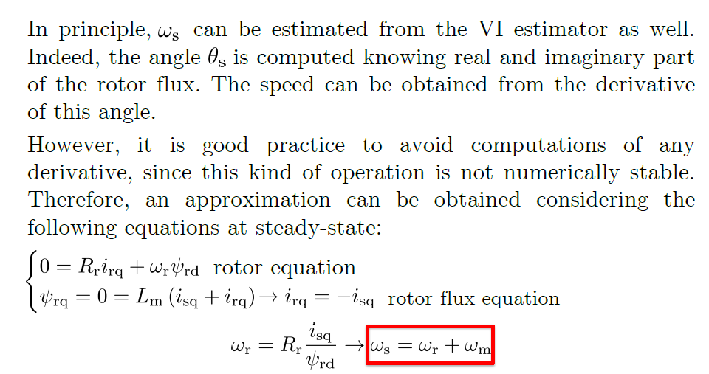

Exercise and data (please refer to the code at the end of the report):

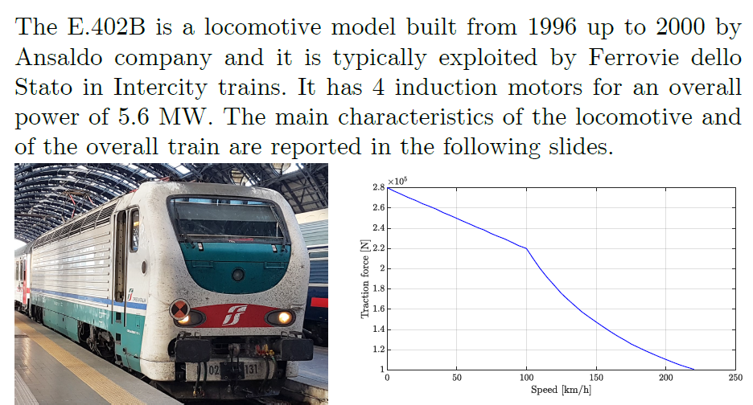

Results:

Speed profile in km/h:

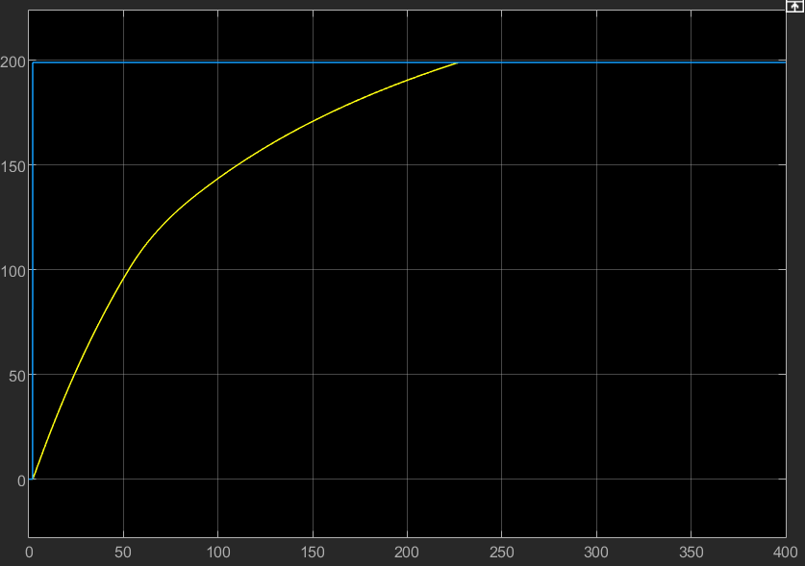

Note:

* The profile simulates a max acceleration and the step reference start from 2 sec, this because in those 2 sec there is time to create some rotor flux and have available starting torque.
* The reference is followed slower after 100km/h, infact there is lower accelleration since the train is running over its based speed.
* In the reality, in case of starting without the presence of rotor flux, there is a buttom on train that applied just isd current to create some initial flux.
* Actually, when the train reaches a certain velocity, it switches off the traction force up to a min speed sensed and then it turns on and so on: coasting mode.

Isq current in A:

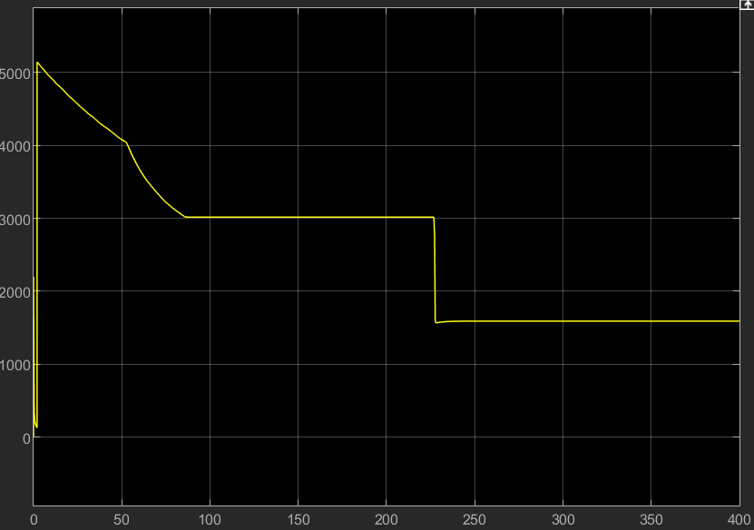

The current at the beginning decrease due to the flux weakening and then it is stabilized just to win the friction forces.

The profile of the isd current is:

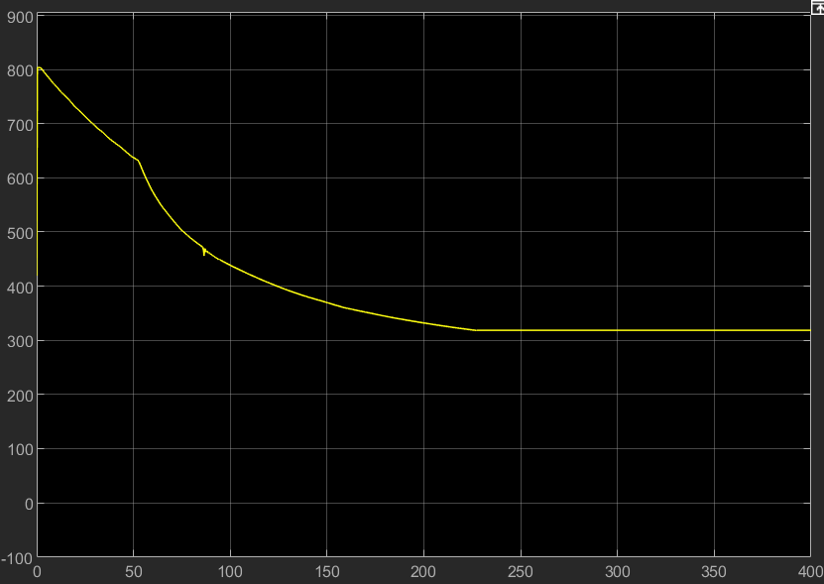

While the profile of the rotor flux has still the same shape (due to the flux weakening) and with max value set at almost 7Wb:

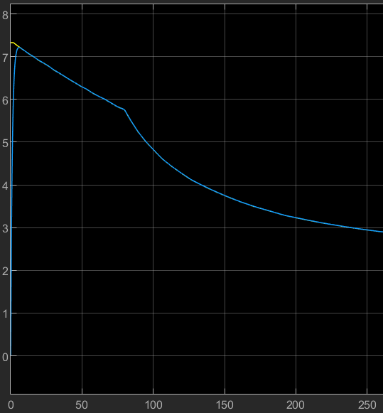

Code:

clc

clear all

%% DC machine parameters

load('Traction_e402B_online');

%parameters of 1 motor = equivalent motor

V_motor = 1860; %voltage of each motor

V_max=V_motor*sqrt(3);

pp=2; %pole pairs of each motor

cos_fi=0.85; %power factor of each motor

Rs=0.01; %p.u.

Rr=0.01; %p.u.

X_lock=0.1; %p.u.

X_noload=3.5; %p.u.

d=1250*10^-3; %diameter wheels

tr=23/91; %trasmission ratio

mass_tot=89*10^3+11*47*10^3+45*80+45*15; %kg

v_max=200*1000/3600; %max speed m/s

omega_max=v_max/tr/d*2; %rad/s

eff=0.9; %efficiency

J=mass_tot*v_max^2/omega_max^2;

%J_eq=mass_tot*(tr*d)^2/4;

Pn=5.6*10^6; %tot mechanical power [W]

Pe_tot=Pn/eff;

I_motor=Pe_tot/sqrt(3)/V_motor/cos_fi;

Z=V_motor/I_motor;

Rs_eq=Rs*Z;

Rr_eq=Rr*Z;

X_lock_eq=X_lock*Z;

X_noload_eq=X_noload*Z;

Rks=Rs_eq+Rr_eq;

Lks=X_lock_eq/(2*pi*50);

M=(X_noload_eq)/(2*pi*50);

F_friction=62000; %N at v_max

T_friction=F_friction/2*d/2*tr; %at 100km/h base speed

omega_b=100*1000/3600/tr/d*2;

psi_r_max=V_motor*sqrt(3)*0.8/(omega_b*pp);

k=traction(1,2)/psi_r_max;

psi_rd_ref = traction(:,2)/k;

speed_ref = traction(:,1);

id_ref=psi_rd_ref/M;

Tn = Pn/omega_b; % Nominal torque provided by the machine

iq_max=1000*traction(1,2)*d/2*tr/pp/psi_r_max;

tau_s=Lks/Rs;

B=T_friction/omega_b;

tau_O=J/B;

tau_psi=M/Rr_eq;

% B = Tfriction/rated_speed_motor; % friction coefficient < Or

% tau_mec=J_eq/B;

%% PI controller design parameters

s=tf('s');

%Gi

tau_s_desired=tau_s/100;

wc_s=2*pi/tau_s_desired;

%GO

tau_O_desired=tau_O/1000;

wc_O=2*pi/tau_O_desired;

%Gpsi

tau_psi_desired=tau_psi/1000;

wc_psi=2*pi/tau_psi_desired;

%tf

Gi = 1/(Rs+Lks*s);

GO = 1/(B+J*s);

Gpsi = (1/M)/(1+(M/Rr_eq)*s);

%% Zero Pole cancellation (90 phase margin)

% %PI parameters ia

% kp_a=wc_a*La;

% ki_a=wc_a*Ra;

% Regi=kp_a+ki_a/s

% Ti_a=kp_a/ki_a;

% %tf open loop

% Li=Regi*Gi;

% %tf close loop

% Fi=Li/(1+Li);

% % figure

% % bode(Li)

% % figure

% % bode(Fi)

% %PI parameters ie

% kp_e=wc_e*Le;

% ki_e=wc_e*Re;

% Rege=kp_e+ki_e/s

% Ti_e=kp_e/ki_e;

% %tf open loop

% L_e=Rege*Ge;

% %tf close loop

% Fe=L_e/(1+L_e);

% % figure

% % bode(L_e)

% % figure

% % bode(Fe)

% %PI parameters speed

% kp_O=wc_O*J_eq;

% ki_O=wc_O*B;

% RegO=kp_O+ki_O/s

% Ti_O=kp_O/ki_O;

% %tf open loop

% LO=RegO*GO;

% %tf close loop

% FO=LO/(1+LO);

% % figure

% % bode(LO)

% % figure

% % bode(FO)

%% Pidtool

%otherwise use pidtool

phase_m=90;

%pidtool(Gi)

opt=pidtuneOptions('PhaseMargin', phase_m);

par_regi=pidtune(Gi,'PI',wc_s,opt);

ki_s=par_regi.Ki;

kp_s=par_regi.Kp;

Regi=kp_s+ki_s/s

Ti_s=kp_s/ki_s;

%tf open loop

Li=Regi*Gi;

%tf close loop

Fi=Li/(1+Li);

% figure

% bode(Li);

% figure

% bode(Fi);

% figure

% margin(Li);

%pidtool(GO)

par_reg_speed=pidtune(GO,'PI',wc_O,opt);

ki_O=par_reg_speed.Ki;

kp_O=par_reg_speed.Kp;

RegO=kp_O+ki_O/s

Ti_O=kp_O/ki_O;

%tf open loop

LO=RegO*GO;

%tf close loop

FO=LO/(1+LO);

% figure

% bode(LO);

% figure

% bode(FO);

% figure

% margin(LO);

%pidtool(Gpsi)

par_reg_speed=pidtune(Gpsi,'PI',wc_psi,opt);

ki_psi=par_reg_speed.Ki;

kp_psi=par_reg_speed.Kp;

Regpsi=kp_psi+ki_psi/s

Ti_psi=kp_psi/ki_psi;

%tf open loop

Lpsi=Regpsi*Gpsi;

%tf close loop

Fpsi=Lpsi/(1+Lpsi);

% figure

% bode(LO);

% figure

% bode(FO);

% figure

% margin(LO);